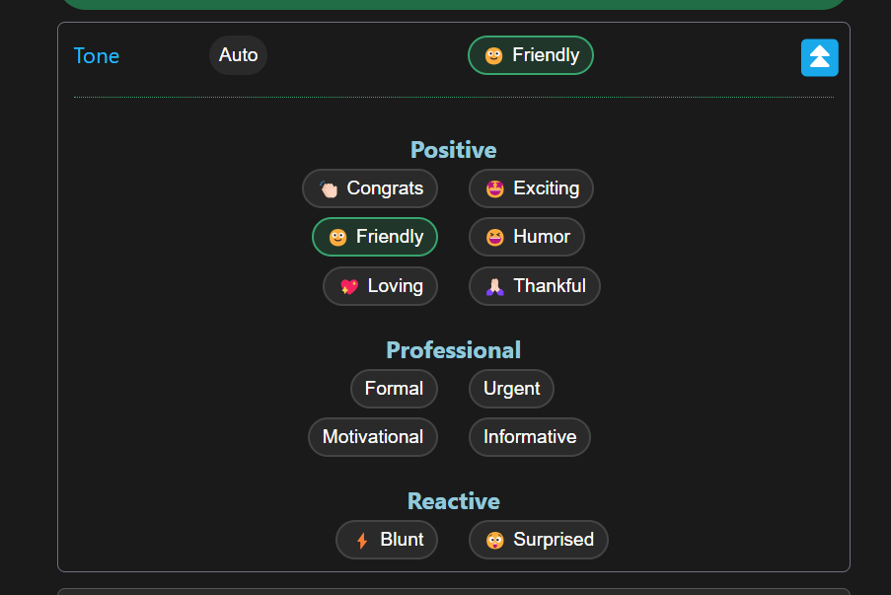

**AI-Enhanced Communication**

1. **Automated Text Refinement**: Uses NLP models to analyze and restructure sentences, improving clarity, grammar, and tone almost instantaneously.
2. **Context-Aware Personalization**: Leverages contextual understanding to adapt content for specific audiences, channels (email, SMS, social), or tones (formal, friendly, concise, etc.).
3. **Efficiency Through Automation**: Reduces manual editing time by employing pretrained language models (such as GPT or T5) to handle rephrasing and correctness.
4. **Enhanced Consistency**: Standardizes language and style across large volumes of communication, helping businesses maintain a cohesive voice.
5. **Accessibility Improvement**: Democratizes writing quality by allowing users-regardless of native language or writing expertise-to produce professional-level text.
6. **Feedback-Driven Optimization**: Systems can iteratively learn from user feedback, fine-tuning transformations for even better relevance and accuracy.
7. **Multifunctional Integration**: Easily integrates into workflow tools and messaging platforms through APIs, supporting real-time assistance, multilingual rewriting, and domain-specific adaptations.

**Tech Stack**

**Frontend:**

* **HTML5 (public/index.html):** Defines the structure and content of the web page users interact with.
* **CSS3 (public/style.css):** Provides all the visual styling, layout, and responsiveness for the application.
* **Vanilla JavaScript (ES6+) (public/script.js):** Handles all client-side logic, user interactions, API calls, and dynamic UI updates.
* **SVG:** Used for scalable vector graphics, specifically for icons like the signature button, ensuring sharp display at any size.
* **Web Share API:** Enables native sharing functionality through the operating system's share dialog if available.
* **Web Speech API:** Allows for converting spoken audio into text for the input area (currently hidden/inactive UI).

**Backend:**

* **Node.js:** The JavaScript runtime environment that executes the server-side code.
* **Express.js (api/improve.js):** A minimal web framework used to create the API endpoint, handle requests, and manage routing.
* **axios:** A library for making HTTP requests, used here to communicate with the external OpenAI API.
* **dotenv:** Loads sensitive configuration like API keys from a .env file into environment variables.

**External Services:**

* **OpenAI API (GPT-4o):** The core AI service that takes the user's text and instructions (type, tone) and generates the improved version.

**Development/Deployment:**

* **nodemon:** A development tool that automatically restarts the Node.js server when file changes are detected.
* **concurrently:** A utility to run multiple command-line tools (like the server and browser-sync) simultaneously.
* **browser-sync:** A development tool that automatically reloads the browser or injects CSS changes without a full page refresh.
* **Vercel:** The cloud platform used for hosting the live web application and managing deployments.
* **Vercel Analytics:** A service integrated into the frontend to gather usage statistics for the deployed application.